**Premodel exam(Hari prasad s,19222111)**

5.write a c++ program to intialized string with saveetha and replaced all vowles in captial.

#include <iostream>

#include <string>

using namespace std;

int main() {

string input;

cout << "Enter a string: ";

getline(cin, input);

for (int i = 0; i < input.length(); i++) {

if (input[i] == 'a' || input[i] == 'e' || input[i] == 'i' || input[i] == 'o' || input[i] == 'u' ||

input[i] == 'A' || input[i] == 'E' || input[i] == 'I' || input[i] == 'O' || input[i] == 'U') {

if (islower(input[i])) {

input[i] = toupper(input[i]);

} else {

input[i] = tolower(input[i]);

}

}

}

cout << "Converted string: " << input << endl;

return 0;

}

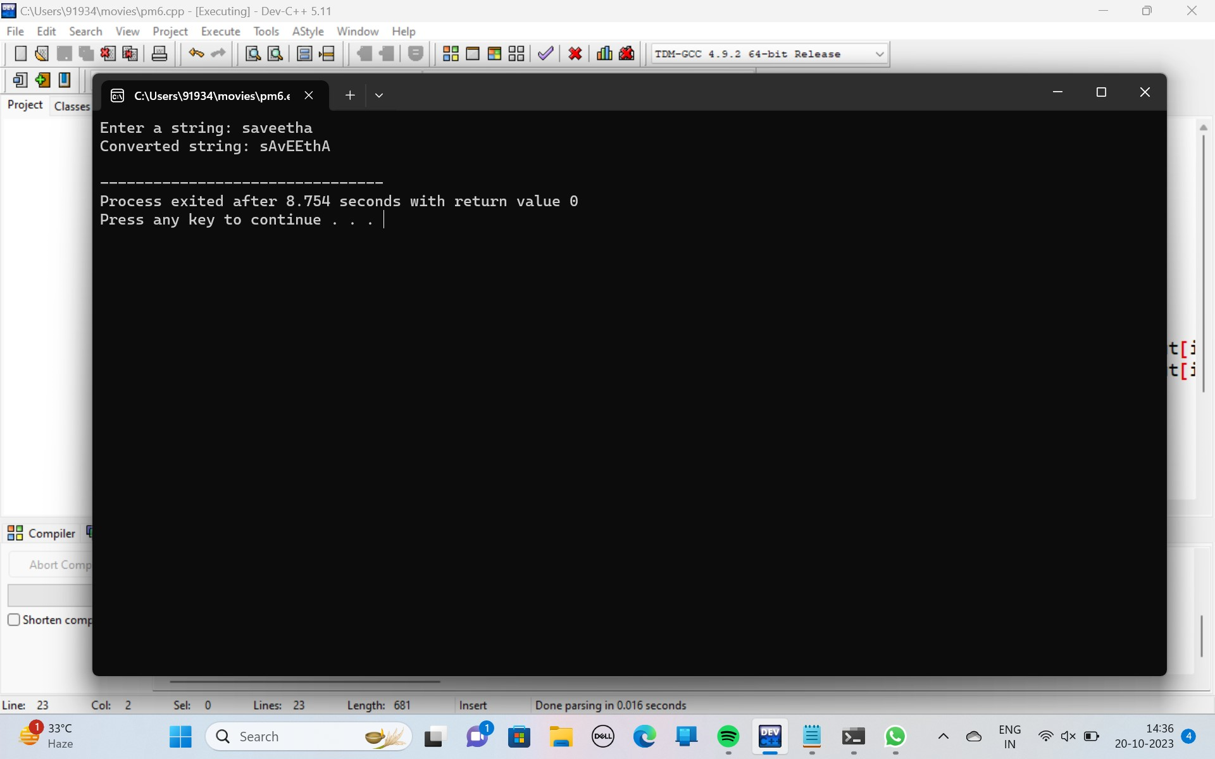

6.write a c++ program to get number from user and read the even digit alone place in the array and display.

#include<iostream>

using namespace std;

int main()

{

int arr[100],n, i;

cout<<"Enter size of the array numbers: ";

cin>>n;

cout<<"enter the elements:"<<endl;

for(i=0; i<n; i++)

cin>>arr[i];

cout<<"\nEven Numbers are:\n";

for(i=0; i<n; i++)

{

if(arr[i]%2==0)

cout<<arr[i]<<" ";

}

cout<<endl;

return 0;

}

